Ideation Phase

Brainstorm & Idea Prioritization Template

Date | 31 October 2025
Team ID | NM2025TMID05934
Project Name | Optimizing User, Group, and Role Management with Access Control and Workflows
Maximum Marks | 4 Marks

Brainstorm & Idea Prioritization:
To effectively resolve the challenges associated with managing users, groups, and roles in the ServiceNow environment, an extensive brainstorming session was organized with the development and administration teams. The primary objective of this session was to generate practical, innovative, and sustainable ideas that could streamline workflow efficiency, strengthen access management, and minimize manual intervention. During the ideation phase, multiple approaches were proposed. Team members discussed automation of user provisioning and role assignments to reduce human error and enhance productivity. Integrating approval workflows was identified as a method to
ensure accountability and transparency in user access requests. Additionally, the implementation of Access Control Lists (ACLs) was explored to provide a
secure and structured way of defining data access permissions.
Once all potential solutions were gathered, the team evaluated them using key parameters such as impact on system performance, feasibility within existing infrastructure, cost-effectiveness, and ease of implementation. This structured evaluation enabled the identification and prioritization of the most beneficial initiatives. The top priorities included developing automated user management workflows, establishing clear and consistent role hierarchies, and designing approval-based access workflows through ServiceNow Flow Designer. This collaborative brainstorming and prioritization exercise proved instrumental in driving the project’s success. It encouraged cross-functional knowledge sharing, improved decision-making, and ensured that all proposed solutions aligned with the organization’s security and operational goals. As a

result, the final implementation roadmap focused on strategies that not only enhanced administrative efficiency but also reinforced data protection and compliance standards within the ServiceNow platform.
Step 1: Team Gathering, Collaboration and select the Problem Statement
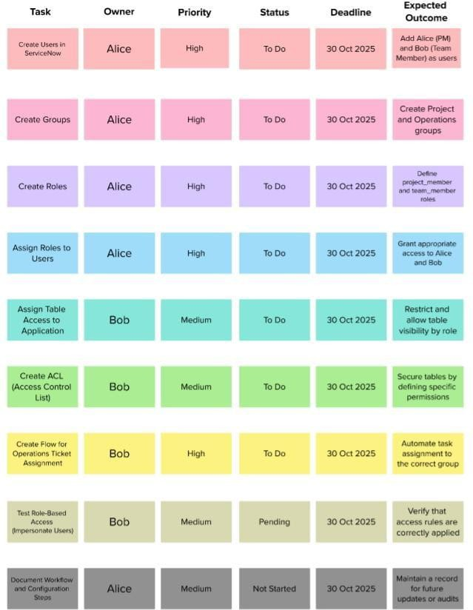

Step 2: Brainstorm, Idea Listing, Grouping and Idea Prioritization

